this() Constructor Call – Complete Explanation
this() is a special constructor call used to invoke another constructor of the same class.
Its main purpose is to reuse constructor logic and avoid repeating initialization code.

Why this() Is Needed
In many classes, different constructors perform similar initialization work.
Instead of writing the same code in every constructor, this() allows one constructor to delegate the work to another constructor.
This makes the code:
- Cleaner
- Easier to maintain
- Less error-prone

How this() Works Internally
When this() is executed:
- Control moves from the current constructor to another constructor of the same class.
- The target constructor executes completely.
- After it finishes, control returns back to the calling constructor.
- The remaining statements of the calling constructor then execute.
👉 Important idea:
All constructors operate on the same object in Heap memory, not on new objects.

Constructor Chaining Using this()
Calling one constructor from another constructor using this() is called
constructor chaining inside the same class.
This allows initialization to happen step by step, in a controlled order.

Rules of this() Constructor Call
- this() must be the first statement in a constructor.
- this() and super() cannot appear together in the same constructor.
- Only one constructor call (this() or super()) is allowed as the first line.
- this() can be called:
  - With no arguments → calls no-argument constructor
  - With arguments → calls the matching constructor
- A constructor with matching parameters must exist, otherwise compilation fails.

Relation Between this() and super()
- If this() is used, the compiler does not insert super() in that constructor.
- The final constructor in the this() chain will contain either:
  - An explicit super(), or
  - An implicit super() added by the compiler

👉 Important flow concept
When constructors are linked using this(), the last constructor always calls super() to complete object creation.

Why this() Must Be First
this() must be the first line so that constructors run in a proper order.
All constructor calls must finish before any other code is executed.
Java enforces this rule to make object creation safe and predictable

When this() and super() Are Used (With Real-Time Example)
Real-Time Scenario
Consider an application where we create Employee objects.
An employee is a person, so employee data must include person details first and then employee-specific details.

Parent Class (Common Details)
class Person {
String name;

// Parent constructor
Person(String name) {
this.name = name;
System.out.println("Person details initialized");
}
}
👉 This constructor initializes common fields required for all persons.

Child Class (Using this() and super())
class Employee extends Person {
int empId;
String role;

// Constructor 1: only name is known
Employee(String name) {
super(name); // initialize parent class part
System.out.println("Employee basic info initialized");
}

// Constructor 2: name and employee id are known
Employee(String name, int empId) {
this(name); // reuse constructor of same class
this.empId = empId;
System.out.println("Employee id initialized");
}

// Constructor 3: full employee details
Employee(String name, int empId, String role) {
this(name, empId); // reuse existing initialization
this.role = role;
System.out.println("Employee role initialized");
}
}

Main Method
public class Company {
public static void main(String[] args) {
Employee emp = new Employee("Pavan", 101, "Java Developer");
}
}

What This Example Clearly Shows
When this() Is Used
- Used to reuse constructor logic within the same class
- Avoids repeating code for initializing common fields
- Helps keep constructor logic centralized and clean
👉 In the example:
this(name) and this(name, empId) reuse logic already written in another constructor.

When super() Is Used
- Used to initialize the parent class part of the object
- Ensures parent class fields are ready before child class fields
- Mandatory in every object creation (explicit or implicit)
👉 In the example:
super(name) initializes the Person part of the Employee object.

Constructor Chaining Flow (Simple Understanding)
- Employee(name, empId, role) is called
- this(name, empId) executes
- this(name) executes
- super(name) executes → parent initialized first
- Control returns step by step
- Child fields are initialized
- Object creation completes

Final Notes-Perfect Conclusion
- Use this() when constructors in the same class share common initialization logic.
- Use super() when a constructor must initialize the parent class.
- this() improves code reuse.
- super() ensures proper object creation order.
- Object creation finishes only after all parent and child constructors execute.

One-Line Memory Lock 🔒
this() reuses constructor logic within the same class, while super() initializes the parent class during object creation.

Constructor Overloading
Constructor overloading means having more than one constructor in the same class, so that objects can be created in different ways.

Rules for Constructor Overloading
- All constructors must have the same name as the class
→ because constructors are identified by the class name.
- Constructors must differ in their parameter list
→ either by:
  - different number of parameters, or
  - same number of parameters with different data types.
- Return type is not considered for constructor overloading
→ constructors do not have return types, not even void.
- Access modifiers can be different for overloaded constructors
→ constructors can be public, protected, private, or default.
- Parameter names do not matter, only parameter types and order matter
→ changing only variable names does not create overloading.
- Order of parameters matters when data types are different
→ (int, String) is different from (String, int).
- Each overloaded constructor can contain different initialization logic
→ based on the data provided during object creation.
- Overloaded constructors can call each other using this()
→ to reuse common initialization code.
- At least one constructor in the chain must call super()
→ either explicitly or automatically, to initialize the parent class.
- Constructor overloading is resolved at compile time
→ the constructor is chosen based on the arguments passed while creating the object.

Note: 1️⃣ About this() and implicit super()
- In constructor chaining, even if all constructors use this(),
- The last constructor in the chain (the one that does not call this()),
- will get super() implicitly added by the compiler if it is not written explicitly.
👉 That means:
Constructor chaining can never end without calling super().
Why?
- Because Java must initialize the parent class part of the object
- And super() is the only way that happens
So even if you don’t see it in code, super() is always executed at the end of the this() chain.

2️⃣ Is it still constructor chaining if super() is used?
Constructor chaining simply means:
Calling one constructor from another constructor
It does not matter whether the call is:
- this() → calling constructor of the same class
- super() → calling constructor of the parent class
Both are constructor chaining.

Constructor Chaining
Constructor chaining means calling one constructor from another constructor.
There are two types:
- this() → calls constructor of the same class
- super() → calls constructor of the parent class

class Employee1 {
private String Emp_name;
private int Emp_id;
private String Emp_role;
// --- Constructor 1 (3 Arguments) ---
// This is where we start when we say new Employee1("mohan", 987, ...)
public Employee1(String Emp_name, int Emp_id, String Emp_role) {
this(); // (1) First, go to the No-Arg constructor
// (7) We return here LAST. These lines overwrite everything that happened before.
this.Emp_name = Emp_name; // Overwrites "kalyan" with "mohan"
this.Emp_id = Emp_id; // Overwrites 456 with 987
this.Emp_role = Emp_role; // Overwrites "java full stack..." with "java framework..."
}
// --- Constructor 2 (No Arguments) ---
public Employee1() {
this("kalyan"); // (2) Go to the 1-Arg constructor
// (6) We return here after the 1-Arg constructor finishes.
Emp_id = 456;
Emp_role = "java full stack developer";
}
// --- Constructor 3 (1 Argument) ---
public Employee1(String Emp_name) {
// (3) IMPLICIT SUPER CALL: The compiler puts super() here hiddenly.
// Control goes to Object class, initializes memory, and returns.
// (4) Now we execute the body of this constructor.
this.Emp_name = Emp_name; // Sets name to "kalyan" temporarily
// (5) Returns to Constructor 2...
}
// --- Getters ---
public String getEmp_name() {
return Emp_name;
}
public int getEmp_id() {
return Emp_id;
}
public String getEmp_role() {
return Emp_role;
}
}
public class This_Method {
public static void main(String[] args) {
// Start the chain
Employee1 obj = new Employee1("mohan", 987, "java framework specialist");
System.out.println("Name: " + obj.getEmp_name());
System.out.println("ID: " + obj.getEmp_id());
System.out.println("Role: " + obj.getEmp_role());
}
}

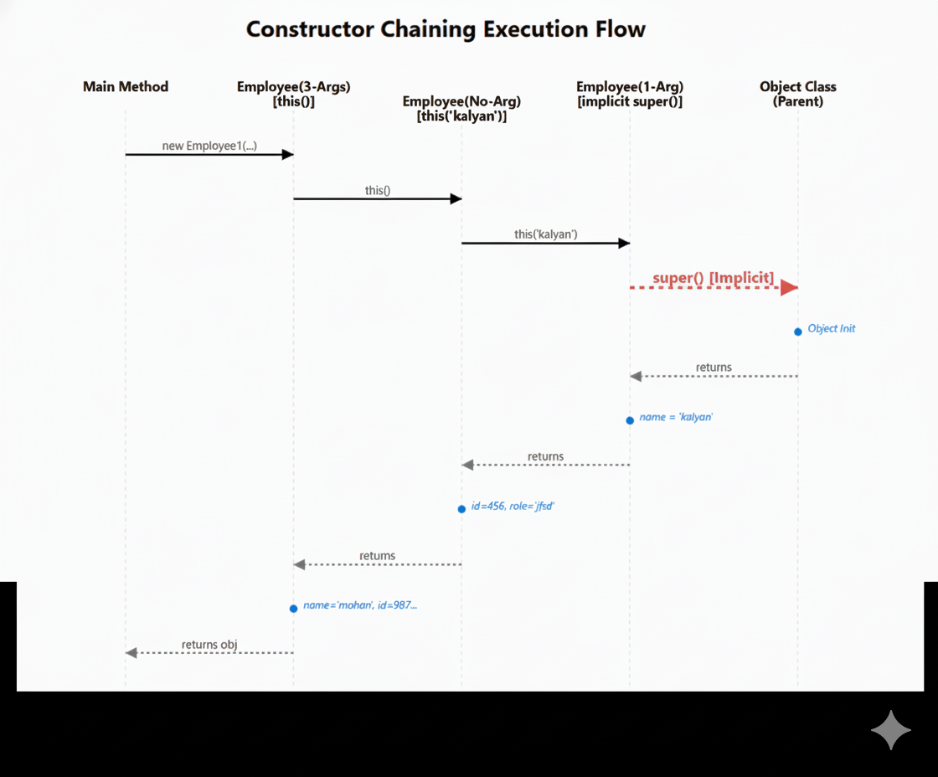

Step-by-Step Execution Flow (Very Detailed & Clear)
We start from the main method.

STEP 0: Program starts
public static void main(String[] args) {
Employee1 obj = new Employee1("mohan", 987, "java framework specialist");
}
- JVM starts execution from main()
- Sees new Employee1("mohan", 987, "java framework specialist")

STEP 1: Object creation in Heap
- JVM allocates memory in Heap for one Employee1 object
- Instance variables get default values:
Variable | Default value
Emp_name | null
Emp_id | 0
Emp_role | null
👉 Important:
Only one object is created.
All constructors will work on this same object.

STEP 2: JVM enters Constructor 1 (3 arguments)
public Employee1(String Emp_name, int Emp_id, String Emp_role) {
this();
...
}
- This constructor is selected because arguments match
- First line is this() → so JVM cannot execute this constructor body yet
- Control immediately jumps to no-argument constructor

STEP 3: JVM enters Constructor 2 (No arguments)
public Employee1() {
this("kalyan");
...
}
- Again, first line is this("kalyan")
- JVM pauses this constructor
- Control jumps to 1-argument constructor

STEP 4: JVM enters Constructor 3 (1 argument)
public Employee1(String Emp_name) {
this.Emp_name = Emp_name;
}
- There is no this() written here
- So compiler automatically inserts super() as the first line
🔹 Implicit step (very important)
super(); // added by compiler
- Control moves to parent class constructor
- Parent class is Object

STEP 5: JVM executes Object class constructor
- Object() constructor runs
- Object-level initialization completes
- Control returns back to Constructor 3
👉 This is where real object creation actually starts from

STEP 6: Execute body of Constructor 3
this.Emp_name = Emp_name;
- Emp_name is set to "kalyan"
- Heap now looks like:
Variable | Value
Emp_name | "kalyan"
Emp_id | 0
Emp_role | null
- Constructor 3 finishes
- Control returns to Constructor 2

STEP 7: Resume Constructor 2 (No-Arg)
Emp_id = 456;
Emp_role = "java full stack developer";
- These lines now execute
- Heap becomes:
Variable | Value
Emp_name | "kalyan"
Emp_id | 456
Emp_role | "java full stack developer"
- Constructor 2 finishes
- Control returns to Constructor 1

STEP 8: Resume Constructor 1 (3-Arg)
this.Emp_name = Emp_name;
this.Emp_id = Emp_id;
this.Emp_role = Emp_role;
- These assignments overwrite previous values
- Final heap state:
Variable | Final Value
Emp_name | "mohan"
Emp_id | 987
Emp_role | "java framework specialist"
- Constructor 1 finishes

STEP 9: Control returns to main()
System.out.println(obj.getEmp_name());
System.out.println(obj.getEmp_id());
System.out.println(obj.getEmp_role());
Output:
Name: mohan
ID: 987
Role: java framework specialist

